6B – Driving – Lesson 01
Running Costs & Depreciation – Fuel Consumption.

Name: _________________
- What is fuel consumption?

- What Units do we use to measure fuel consumption?

- Calculate John’s fuel consumption when driving a Subaru Forester 900 km when using different octane rated fuels (to one decimal place):

  - 91 octane fuel he used 95 litres.

Cost = $1.24/L x 95 L = $ ______

Fuel Consumption = 95L ÷ [900km ÷ 100] = _____ L/100km

  - 95 octane fuel he used 85 litres.

Cost = $1.31/L x ____ = $ ______

Fuel Consumption = ___L ÷ [900km ÷ 100] = _____ L/100km

  - 98 octane fuel he used 83 litres.

Cost = $1.39 x ___ L = $ ______

Fuel Consumption =

  - Which octane rated fuel is the

    - Least expensive? ____

    - Lowest fuel consumption? ____
- Use Redbook.com.au to compare the fuel consumption of a : [Assume 142¢/L}
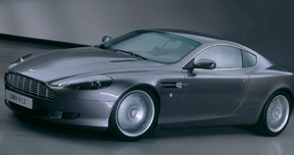
  - New Aston Martin DB9.

    - Fuel Consumption

    - Cost to travel 500 km

Cost = ____ x 5 x $1.42 = $ _____
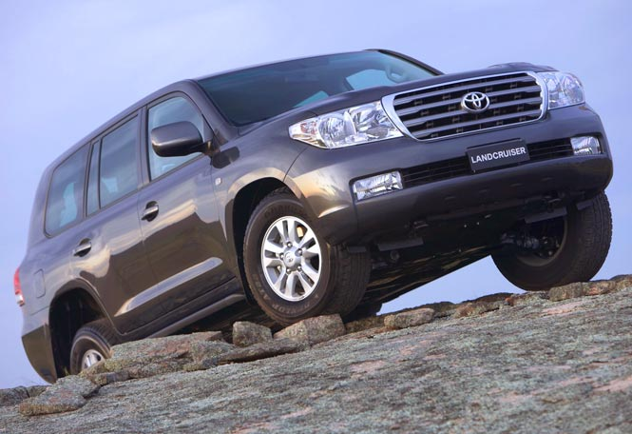
  - New Toyota Land Cruiser.

    - Fuel Consumption

    - Cost to travel 500 km

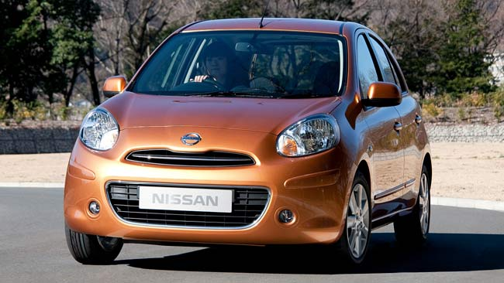
  - New Nissan Micra.

    - Fuel Consumption

    - Cost to travel 500 km

- What is the connection between crude oil priced and the price of unleaded petrol?
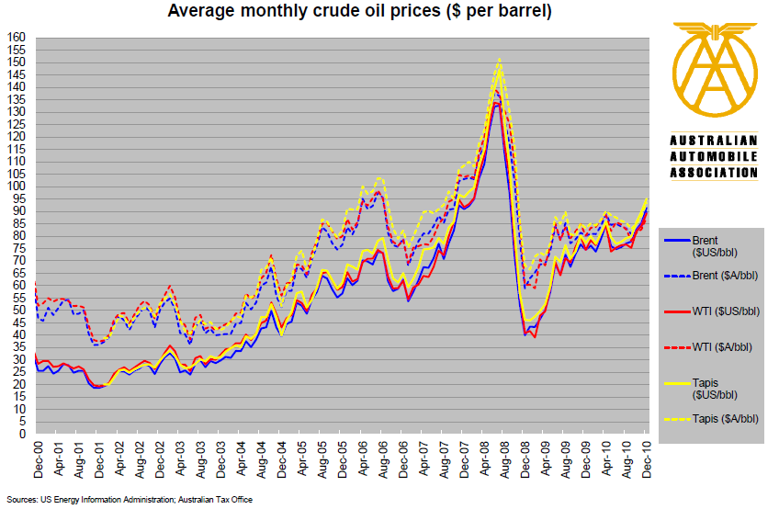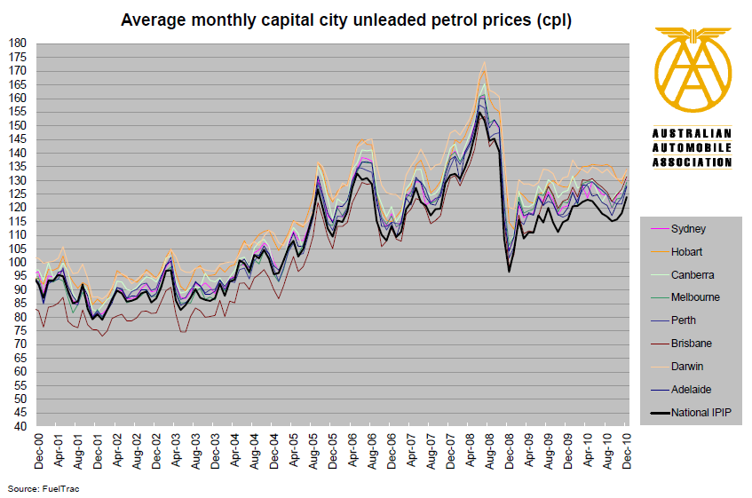

- Use the excel spreadsheet at www.aaa.asn.au/issues/petrol.htm to predict the cheapest and dearest months to buy petrol in Sydney.

  - Cheapest Average Months: _______________________

  - Dearest Average Months: _______________________

